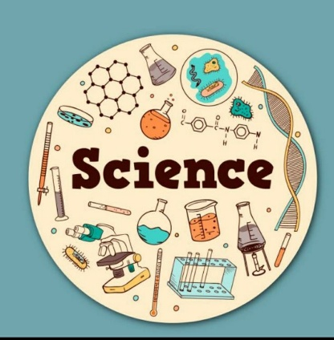
GRADE 5 SCIENCE Homework

UNIT 2: PROPERTIES OF MATTER

Topics 2.1–2.3
Name: ____________________________________
Class: ___________________ Date: ___________________

LEARNING OBJECTIVES
I can:
- Describe properties of substances.
- Identify thermal and electrical conductors and insulators.
- Explain reversible changes.
- Use observations to answer scientific questions.

2.1 PROPERTIES OF SUBSTANCES

A. Definitions
Write the meaning of each word.
Property | Meaning
1. Hardness
2. Solubility
3. Melting point
4. Electrical conductivity

B. CHOOSE THE CORRECT ANSWER
1. Which is a property of a substance?
☐ A. Colour
☐ B. Owner
☐ C. Location
☐ D. Price
2. What does the melting point tell us?
☐ A. How heavy a substance is
☐ B. The temperature at which it melts
☐ C. How much water it contains
☐ D. How quickly it moves
3. Which substance is likely to have the highest melting point?
☐ A. Ice
☐ B. Chocolate
☐ C. Iron
☐ D. Butter

C. USE THE DATA
Three substances have the following melting points:
Substance | Melting Point
A | 25°C
B | 80°C
C | 150°C
1. Which substance has the highest melting point?

2. Which substance will melt first when heated?

3. Why can melting point help scientists identify a substance?

2.2 THERMAL AND ELECTRICAL CONDUCTORS

A. COMPLETE THE SENTENCES
Use:
thermal • electrical • conductor • insulator
- A material that allows heat to pass through easily is a thermal __________________________.
- A material that does not allow heat to pass through easily is a thermal __________________________.
- A material that allows electricity to pass through easily is an electrical __________________________.
- Rubber is usually an electrical __________________________.

B. SORT THE MATERIALS
Sort the materials into the correct groups.
copper • plastic • aluminium • rubber • wood • iron
CONDUCTORS | INSULATORS

C. EXPLAIN
Why are saucepan handles often made from plastic or wood instead of metal?

VIDEO ACTIVITY

MELTING POINTS AND HEAT TRANSFER
Your teacher will show you a video using different types of spoons and hot water.
Conductors and insulators
Video: https://www.youtube.com/watch?v=M7g5MwExn8k.
Watch carefully and record your observations.

OBSERVATIONS
1. What happened to the different spoons when they were placed in hot water?

2. Which spoon became hot the fastest?

3. Which spoon became hot the slowest?

4. Which material was the best thermal conductor?

5. Which material was the poorest thermal conductor?

THINK LIKE A SCIENTIST
6. What property of the spoon materials was being investigated?

7. Was the investigation about thermal conductivity or electrical conductivity?

8. Explain your answer.

2.3 REVERSIBLE CHANGES (Video)
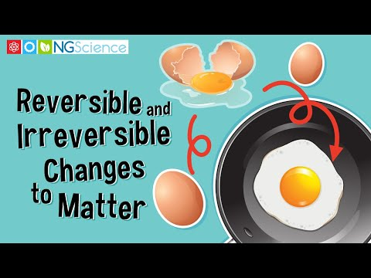

A. CHOOSE THE CORRECT ANSWER
1. Which is a reversible change?
☐ A. Burning paper
☐ B. Melting ice
☐ C. Cooking an egg
☐ D. Burning wood
2. When water freezes, it changes from:
☐ A. Solid → liquid
☐ B. Liquid → gas
☐ C. Liquid → solid
☐ D. Gas → liquid
3. How can melted ice be changed back into ice?
☐ A. Heat it
☐ B. Freeze it
☐ C. Burn it
☐ D. Mix it with oil

B. REVERSIBLE OR IRREVERSIBLE?
Write R for reversible or I for irreversible.
Change | R / I
Melting chocolate
Burning wood
Freezing water
Melting candle wax
Cooking an egg
Breaking a piece of glass

C. EXPLAIN YOUR THINKING
1. Why is melting ice a reversible change?

2. Give TWO examples of reversible changes.

SCIENTIFIC INQUIRY
Mica wants to investigate which type of spoon transfers heat the fastest.
They have:
- Metal spoon
- Wooden spoon
- Plastic spoon
- Hot water
- Three identical containers

1. Write a scientific question.

2. What will the learner change?

3. What will the learner observe or measure?

4. Name ONE thing that should be kept the same.

5. Which spoon do you predict will transfer heat fastest?

6. Explain your prediction.

CHALLENGE QUESTIONS

1. Two spoons look similar. One is metal and one is plastic.
How could you test which spoon is the better thermal conductor?

2. A learner says:
“If a substance melts, it has become a new substance.”
Do you agree?
☐ Yes
☐ No
Explain your answer.

3. Why is knowing the properties of materials important when choosing materials to make objects?

MY SCIENCE CHECK
I can… | Yes | Almost | Not yet
Describe properties of substances | ☐ | ☐ | ☐
Explain melting point | ☐ | ☐ | ☐
Identify thermal conductors and insulators | ☐ | ☐ | ☐
Identify electrical conductors and insulators | ☐ | ☐ | ☐
Identify reversible changes | ☐ | ☐ | ☐
Explain observations from an investigation | ☐ | ☐ | ☐

ONE THING I LEARNED:

ONE QUESTION I STILL HAVE:

